New Mexico State Personnel Office
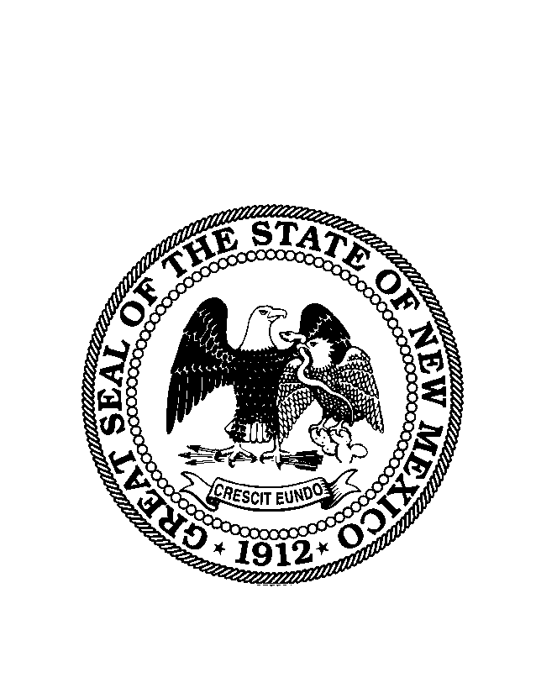
2600 Cerrillos Road
Santa Fe, New Mexico 87505-0127

Classification Description

ALTERNATIVE DISPUTE RESOLUTION (ADR)

Class Title Class Code Pay Band Alt Pay Band*
ADR Coordinator H10221 65

* In accordance with SPB Rule 1.7.4.11 NMAC, the assignment to alternative pay bands shall be reviewed annually to determine their appropriateness.

Occupation Description
Incumbents in this classification promote dispute prevention and alternative dispute resolution as a cost-effective means of resolving issues, problems or complaints before they progress to formal procedures.

Nature of Work

- Develops and maintains procedures for settling disputes in an expedited manner by means other than litigation.

- Fosters long term relationships among agency personnel, clients, vendors, citizens, or other interested parties.

- Promotes an internal appeals procedure as a means of resolving employee complaints before they end up as a charge with an agency such as the EEOC or in litigation.

- It is critical that the ADR Coordinator be perceived as a neutral, confidential, and accessible resource for the early intervention and resolution of conflicts.

Distinguishing Characteristics
Work is under direct supervision of an agency head: ensures compliance with Federal, State, and Local laws, regulations and state statutes governing employment and dispute prevention, resolution and management.
- Works with state Office of Alternative Dispute Prevention and Resolution to ensure consistency of mediation process.
- Works with employee relations, human resources and personnel management, labor-management representatives, other state of federal agencies, and the general public.
- Develop, implement and coordinate an agency dispute prevention and resolution plan and corresponding agency rules, policies, procedures for the use of ADR.
- Acts as the agency’s primary point of contact on all matters related to ADR
- Identifies and coordinates qualified mediators to facilitate mediations.
- Serves as a mediator and/or facilitator in employment and other program area disputes.
- Conducts intake of potential participants in mediation situations.
- Conducts informal and formal interviews to assess each participant’s readiness to mediate.
- Conducts management and employee training sessions to promote mediation and provide basic level mediation training to employees
- Conducts presentations and develops informational packets to market ADR and mediation processes.
- Attends various meetings, conferences, trainings and education programs.
- Exhibits confidentiality with respect to all matters regarding ADR; employee cases, records, reports; remains neutral and accessible resource for the early intervention and resolution of conflicts.
- Compiles and maintains records and statistics of the ADR operations.
- Prepares written and oral reports and responds to requests for information.
- Develops a tracking system (measurement tool) and aggregate information to determine return on investment for ADR and mediation services and to comply with Governmental Dispute Prevention and Resolution Act’s reporting requirements.
- Communicates with agency Human Resources staff, Loss Control Coordinator, Risk Management Division, and state Office of Alternative Dispute Prevention and Resolution.
- Maintains cooperative working relationships with related state, court, community and other governmental and private agencies in order to achieve general organizational goals as well as specific project goals.

Recommended Experience and Education Standards
Experience in one or more applicable areas including, but not limited to, public administration, alternative dispute resolution program development, regulatory law, or experience in mediation or facilitation is preferred. Bachelor’s degree in public administration, business management, social services, political science; or any combination of education, training, and experience will be accepted that provides the desirable qualifications.

Statutory Requirements: § 12-8A1 through 10 NMSA 1978 (Governmental Dispute Prevention and Resolution Act).

Conditions of Employment: Must have completed a minimum of forty hours basic mediation training/dispute resolution training, to be supplemented by continuing educational courses. Must have attended ethical standards training and understand the application of these standards in practice. Work is performed in an office environment; continuous contact with attorneys, litigants, other staff and the general public. Work requires occasional moderate lifting of objects weighing up to 25 pounds.

Default FLSA status: Non-Exempt. FLSA status may be determined to be different at the agency level based on the agency’s utilization of the position.

Bargaining Unit: This position may be covered by a collective bargaining agreement and all terms/conditions of that agreement apply and must be adhered to.

Established: 11/13/2009

Classification description subject to change. Please refer to the SPO website www.spo state.nm.us to ensure this represents the most current copy of the description.

