Today Date: | FMD/Project Manager Pre-Approval Signature-Date: |  |  |  | Agency Contact Name: |  |  |  | Phone Number:
Requesting Agency
Agency Name:

Address-City:
Modification Site
Agency Name:

Address-City:
Type of request:  Other |  | Expansion |  | Reduction |  | Reconfiguration  Workspace |  | Replace Antennas  Equipment
Electrical  Add/remove |  | Remove/Add  Doors-Walls |  | Security |  | Carpet/Flooring |  | ADA Compliance  Ramps-door
Add No.  FTE’s #  Fill in SNQ |  | Removing No.  FTE’s #  Fill in SNQ
Location of Project Floor/Bldg.: |  |  | Estimated Date of Project to Begin: |  |  |  | Source of Funds:

AGENCY CERTIFICATION
I certify that this request is accurate and complete; is for the minimum amount of space required; is in compliance with State of New Mexico Space Standards, including all laws and executive orders governing the location of space; and those funds are available for payment of rent, moving expenses, telecommunication expenses, and any related reimbursable costs. I further understand that any alterations or improvements will become a part of the Premises and will remain with the Premises upon expiration of this agreement.

Agency Signature: |  | Phone No.: | Date:
Print Name: | Print Title:

FMD-Date Inspected: | PM Approval Signature:

IF you are adding FTE’s you must submit a Space Needs Questionnaire. Include all of the staff in this bureau/division

ATTACH SPACE NEEDS QUESTIONAIRE FOR ADDING ADDITIONAL WORKSPACE
Tabs Include (Standards Submission-Functional-Workstations-Meetings-Equipment-Other office Support space)
LOCATED AT GSD-FMD’S
WEBSITE- Bureaus-Asset Management/Overview
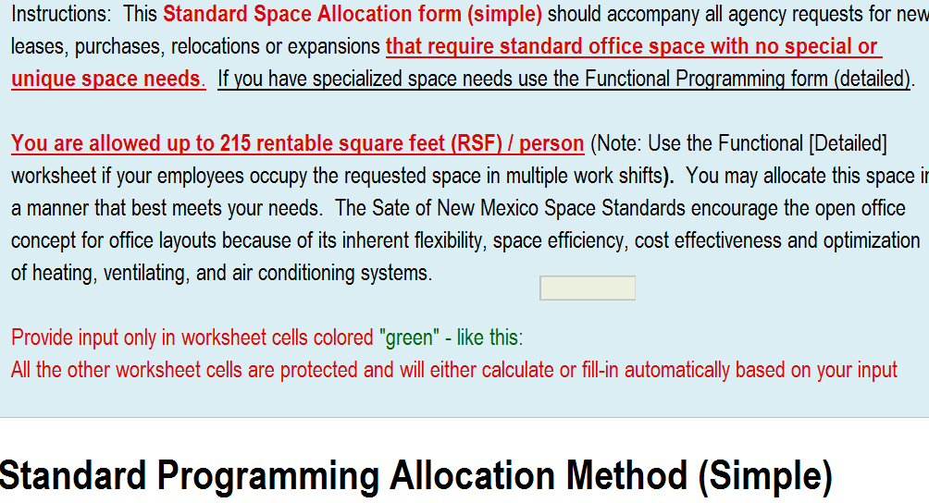

Alteration to Premises - Buildings and Grounds:
Any changes or alterations to the existing structures or modification to the property MUST be approved by the Facilities Management Division. The Facilities Management Division has established a Modification Committee that is responsible for reviewing and approving all changes to State owned property. All Agencies must submit the modification form(s) as follows:
1. Download the Modification form with instructions from the General Services Department – Facilities Management Division web page. http://www.generalservices.state.nm.us/facilitiesmanagement/Forms_and_References.aspx
2. All information required by the instructions will be provided.
3. All requests will include a scope of work, funding source, price quotes and drawings.
4. The Facility Coordinators will present their alteration request to the Modification Committee. The agency may invite contractors, to present proposals and answer technical questions.
5. The Modification Committee will meet and decide whether all requirements were met and approved, request additional information or disapprove the request.
6. Any alterations or improvements will become a part of the Premises and will remain with the Premises upon expiration of this agreement.

