Emergency Evacuation Plan (EEP)

Building Name Building
Street Address

City, State, Zip

Revision Date (Month/Year

Agency 1

Agency 2

Agency 3

Developed by Building Name Building Evacuation Team

Revision Log
Check the applicable box.
Status: New Major revision Minor revision Reviewed - no change
Description/Comments: Click here to enter text.
Name |  | Date |  | Signature
Prepared/Reviewed By:
Name. |  | Click here to enter a date.
Name. |  | Click here to enter a date.
Name. |  | Click here to enter a date.
Name. |  | Click here to enter a date.
Name. |  | Click here to enter a date.
Name. |  | Click here to enter a date.

Table of Contents
Revision Log 2
1.0 Introduction and Approval 4
1.1 Introduction 4
1.2 Approval 4
2.0 Roles and Responsibilities 5
3.0 Instructions 6
3.1 Fire Detection – If You Detect A Fire 6
3.2 Use Of A Fire Extinguisher 6
3.2 Evacuation Procedure 7
3.3 Shelter-In-Place 7
3.3.1 Active Shooter, Building Intruder Or Civil Disturbance 7
3.3.2 Tornado Warning: 8
3.3.3 Hazardous Materials (HAZMAT): 8
3.4 Bomb Threat 9
3.4.1 Signs Of A Suspicious Package: 9
3.4.2 If A Bomb Threat Is Received By Phone: 9
3.4.3 If a bomb threat is received by note: 9
3.4.4 If A Bomb Threat Is Evaluated As A Serious Threat: 9
3.5 Return To Normal Operations / Re-entry Procedures 9
4.0 Procedures For Updating The Emergency Evacuation Plan 9
4.1 Actions Effected By Emergency Evacuation Plan 10
5.0 Designated Areas 11
5.1 Unidentified Object Or Threat In The Designated Area: 11
APPENDIX A 13
Evac Site Plan 13
Evac Map 14
APPENDIX B 15
FLOOR WARDEN REPORT 15
APPENDIX C 16
EVACUATION EVALUATION FORM 16
APPENDIX D 17
TELEPHONE/BOMB THREAT CHECKLIST 17
Employee Acknowledgment Form 19

1.0 Introduction and Approval

1.1 Introduction
- The EEP’s purpose is to provide an orderly evacuation and full accountability of all personnel and visitors from the Building Name Building in the event of a Fire, Bomb Threat, Violence in the Workplace, Biological Threat, Chemical Threat, Radiological Threat, or any other threat caused by Natural Causes.
- This EEP describes evacuation procedures, designates responsibilities, provides a mechanism for monitoring and updating the existing EEP, and requires evaluation for effectiveness of the existing evacuation plan. Evacuation drills will be held at least semi-annually (twice per year) and evaluated for effectiveness.
- The Building Name Building Safety Committee will review and update this Emergency Evacuation Plan on an annual basis. A copy of the plan will be distributed to all employees within the building.
- An EEP is a requirement for all state owned and leased office buildings. This is also a requirement of the State, City and Local Fire Codes.
- For the purposes of helping to ensure the safety and security of employees and members of the public, employees shall comply with the procedures contained in this EEP.
- All employees who work in the Building Name Building shall read the EEP and become thoroughly familiar with their role and responsibility for making this EEP work. They shall sign the Acknowledgment of Emergency Evacuation Plan (Page 19) and return it to their respective department’s human resources or personnel bureau

1.2 Approval
Approved by:
_____________________________________ _______________________
Agency 1 Secretary Cabinet Secretary Date

_____________________________________ _______________________
Agency 2 Secretary Cabinet Secretary Date

_____________________________________ _______________________
Agency 3 Secretary Cabinet Secretary Date

_____________________________________ _______________________
State Fire Marshal, State Fire Marshal Date

2.0 Roles and Responsibilities
The following responsible persons or designee are identified as having a primary function in the performance of this Emergency Evacuation Plan.

- First Responder (Fire Dept., State Police, etc.) shall take over as Incident Commander upon their arrival and shall assume command of the incident.

- Incident Commander
- The Incident Commander will be the point of contact for all Area Wardens and emergency services. The Incident Commander will have adequate training to conduct the operations required in the event of an emergency.
- The Incident Commander will wear a GREEN vest for easy identification.
- The Incident Commander, through the Area/Floor Wardens, will keep all agencies informed at all times of the current situation and will work directly with the agencies concerning administrative decisions.
- The Incident Commander will provide a written evaluation of every building evacuation and make recommendations for improving the operation using the Evacuation Evaluation Form (Appendix C).

- Area Warden- Designated area for the Area Wardens is the Staging Area outside the Building Name Building
  - Area Wardens will report directly to the Incident Commander
  - Floor Wardens will wear ORANGE vests for easy identification
  - Conduct accountability “Head Count”
    - Report missing or injured Personnel
  - Will document and report on problems in the evacuation procedures as reported to them by the Floor Warden(s).

- Floor Warden*
- Floor Wardens will report directly to the Area Warden.
- Floor Wardens will wear ORANGE vests for easy identification.
- Floor Wardens should check offices, bathrooms, and other spaces prior to exiting the area
- Ensure corridor doors are closed when exiting, If time permits close office doors.
- Each Floor Warden will immediately report any missing personnel, injuries, or problems to the Area Warden.
- Floor Wardens will report evacuation details on the Floor Warden Report form (Appendix B). They will note any injuries or problems on the report and submit it to the Area Warden for preparing the written evaluation.

- Safety Officer/Loss Control Coordinator – This individual monitors safety conditions and develops measures for assuring the safety of all assigned personnel. Safety Officer will wear a GREEN vest for easy identification. This person will report all safety violations at all times to the Incident Commander. A Triage Area will also be established by the Safety Officer if needed. If possible, Safety Officers should be chosen due to their prior experience and updated certification in First Aid, CPR and Defibrillator operation. Floor Wardens may assist the Safety Officer with their responsibility where needed or applicable.

- EMPLOYEE
- All employees will read the latest version of the EEP and will know what procedures to follow in case of an emergency evacuation.
- Upon notification of an emergency, employees will immediately evacuate the building using the nearest safe exit as the Floor Warden instructs.
- All elevators will shut down automatically and will NOT be usable during an evacuation
- Employees will report to their Area Warden for a head count at the Staging Area (Appendix A).

3.0 Instructions

3.1 Fire Detection – If You Detect A Fire
- Immediately notify the building occupants to evacuate by activating the closest pull station.
- Notify the fire department by dialing “9” (in State buildings) then dial “911”. The information you should give the fire department is:
  - Your name and organization
  - The building name and address
  - The location of the fire (floor and room number)
  - The location of any known occupants
  - All other pertinent information

DO NOT HANG UP THE PHONE UNTIL YOU ARE TOLD TO DO SO BY THE FIRE DEPARTMENT!

3.2 Use Of A Fire Extinguisher

- If the fire is small, use a fire extinguisher to control or extinguish the blaze.
- If the fire continues to spread while using a fire extinguisher & loss of fire control is imminent, evacuate the building immediately!

How To Properly Use A Fire Extinguisher / The P.A.S.S. Method

Pull the Pin at the top of the extinguisher. The pin releases a locking mechanism and will allow you to discharge the extinguisher.

Aim at the base of the fire, not the flames. This is important - in order to put out the fire, you must extinguish the fuel.

Squeeze the lever slowly. This will release the extinguishing agent in the extinguisher. If the handle is released, the discharge will stop.

Sweep from side to side. Using a sweeping motion, move the fire extinguisher back and forth until the fire is completely out. Operate the extinguisher from a safe distance, several feet away, and then move towards the fire once it starts to diminish. Be sure to read the instructions on your fire extinguisher - different fire extinguishers recommend operating them from different distances. Remember: Aim at the base of the fire, not at the flames!!!!

3.2 Evacuation Procedure

- All occupants will close all windows & doors as they exit. Employees should take all their personal items with them, including car keys, purses, etc.
- Do NOT use the elevators
- Evacuate the building by exiting through the nearest Fire Exit
- Stay calm and exit the building as quickly as possible.
- Assist employees and/or people in the building with special needs including mobility limitations or anyone who may be injured. Only use the mechanical equipment such as an “Evacu-Trak” if you have received training on its use. The stairwell areas in the building are designated staging areas in the building for the employees and/or people with disabilities or injured persons. Report any and all persons stationed at the staging area to the Floor Warden.
- At all times, follow the instructions of the Floor Wardens identified by brightly colored safety vests.
- Immediately report all injuries to the nearest Area/Floor Warden and Supervisor. Area/Floor Warden and/or Supervisor should then report the injury to the Safety Officer/Loss Control Coordinator.
- Once outside of the building, report to your Area Warden at the Designated Area. Do not leave this area until directed to do so by the First Responder.

DO NOT GO HOME OR ELSEWHERE, AS IT MAY BE ASSUMED YOU ARE INJURED AND/OR STILL IN THE BUILDING!

3.3 Shelter-In-Place

A situation may occur in which the safety of occupants is best assured by remaining in place in a safe location.
Immediately Go To A Safe Location In Your Building.

3.3.1 Active Shooter, Building Intruder Or Civil Disturbance

- If possible, take refuge in a room that can be locked.
- If possible, close and lock the building’s or room’s door (s). If unable to lock the door secure it by any means possible.
- The room should also provide limited visibility to anyone that is outside of it.
- Hide under a desk, in a closet, or in the corner.
- Silence your cell phone (ringer and vibrate) so as not to identify your location while hiding.
- After getting to a safe location and without jeopardizing your safety, try and obtain additional clarifying information by all possible means (TV, radio, email, etc.)
- Report any suspicious activity if you can do so without jeopardizing your safety
Call 911Only if it is safe to do so.
- When Law Enforcement arrives, remain calm and follow instructions.
  - Put down any items in your hands.
  - Raise your hands and spread your fingers.
  - Avoid quick movements towards officers, such as holding onto them for safety.
  - Avoid pointing, yelling or screaming.
  - Do not stop to ask officers for help or direction when evacuating.
  - Give officers information such as location of shooter, number of shooters, physical description of shooters, number and type of weapons held by shooters, and number of potential victims at the location.

3.3.2 Tornado Warning:

  - Position yourself in the safest portion of the floor area away from glass. Be prepared to kneel facing a wall and cover your head.
  - In high-rise (four stories or more) buildings, vacate the top floor and move to a lower floor. Position yourself in an interior corridor away from glass. Be prepared to kneel facing the wall and cover your head.
  - If time permits, employees of wood-frame or brick buildings with wood floors should leave the building and go directly to a more substantial concrete building.
  - Any employee who encounters a visitor should direct them to take appropriate actions.
  - Any employee that encounters an individual with special needs, including mobility limitations, should assist them if possible.
  - Try and obtain additional clarifying information by all possible means (TV, radio, email, etc.)

3.3.3 Hazardous Materials (HAZMAT):
With accidental or intentional release of toxic chemicals the air quality may be threatened and sheltering in place keeps you inside an area offering more protection.

    - Do not leave the building.
    - Shutoff the HVAC system from bringing in outside air.
    - Locate a designated shelter area within the building or move to an appropriate shelter area that meets the following conditions:
      - Find a room located in an interior space of a hardened structure on the second floor or above. (many chemicals are denser than air and will collect in low areas)
      - Find a room that does not possess any windows or skylights.
      - Have ample space for everyone that is expected to occupy the shelter to sit comfortably.
      - Attempt to block all openings into the room with whatever materials are present in the room such as tape, plastic trash bags, and clothing.
      - Remain sheltered in place until instructed to leave by emergency personnel.
    - Do not use elevators as they may pump air into or out of the building.
    - Any employee who encounters a visitor should direct them to take appropriate actions.
    - Any employee that encounters an individual with disabilities should assist them if possible.
    - Notify the Police Department or emergency response personnel by Calling 911 and give them your location and status.
    - Try and obtain additional clarifying information by all possible means (TV, radio, email, etc.)
REPORTING A SPILL
Call 911 and provide the following details to the dispatcher:

- Your name.
- Contact information.
- Location of the spill.
- Chemical(s) or product(s) involved.
- Approximate quantity.
- Injuries and/or property damage.
- Status of the spill (contained, abating, increasing, etc.)
- Any other information that can assist in identifying, containing, or responding to the spill.

3.4 Bomb Threat

Most bomb threats are received by phone. Bomb threats are serious until proven otherwise. Remain calm and obtain information with the checklist (Appendix D).
DO NOT:
- Use two-way radios or cellular phone; radio signals have the potential to detonate a bomb.
- Evacuate the building until police arrive and evaluate the threat.
- Activate the fire alarm.
- Touch or move a suspicious package.

3.4.1 Signs Of A Suspicious Package:

- No return address
- Excessive postage
- Stains
- Strange odor
- Strange sounds
- Unexpected

3.4.2 If A Bomb Threat Is Received By Phone:
- Remain calm. Use checklist (Appendix D)
- If your phone has a display, copy the number and/or letters on the window display.
- The most crucial information you can obtain from the caller is detonation time, location, and appearance of the bomb.
- Don't hang up. Have someone call 911 from another phone (landline). Give the phone number where the bomb threat is received.

3.4.3 If a bomb threat is received by note:
- Call 911 immediately.
- Do not handle the note.

3.4.4 If A Bomb Threat Is Evaluated As A Serious Threat:
Once the police arrive and have evaluated the situation as being a serious threat, the Floor Warden(s) will alarm occupants in the area by giving 3 blasts of a Whistle or Air Horn, pause and repeat until the occupants in the area have exited the building.

Refer to 3.2 Evacuation Procedure on evacuation Process

3.5 Return To Normal Operations / Re-entry Procedures

The First Responder (Fire Department), FMD Facilities Operations Manager, and/or the Fire Safety Technician shall be the only determining unit to give the “All-Clear” signal. The Incident Commander, upon receiving such notification, will notify the Area Warden who will then begin notifying employees to return to the building.

4.0 Procedures For Updating The Emergency Evacuation Plan

This Emergency Evacuation Plan has been designed to provide the simplest, safest, and fastest method for evacuating all of the employees from the building in the event of an emergency. This plan has taken into consideration the shortest distances to the nearest exit, the number of people using each exit, and the number and type of obstacles each employee will encounter during an evacuation. The effectiveness of this plan will be affected by a variety of items. Among these are the following:

4.1 Actions Effected By Emergency Evacuation Plan

- A significant increase or decrease of employees assigned to a work area.
- The permanent closing of an existing doorway or hallway.
- Construction or removal of permanent walls or room dividers.
- Movement or placement of office equipment or furniture, which may obstruct an established escape route.

Each of these actions must require prior approval so that the existing Emergency Evacuation Plan may be evaluated and revised accordingly. The individual requesting one of the above actions or any action which may affect the Emergency Evacuation Plan will be required to do the following:

8.3 Steps To Obtain Approval Of Changes To Emergency Evacuation Plan

- Write up proposed action(s) with written description/sketches addressing necessary changes to the existing Emergency Evacuation Plan.
- Submit proposal to the Safety Officer, who will then review the proposal for compliance with safety regulations and codes. The Safety Officer will request assistance from the EEOC. The Safety Officer will then place a proposal review with the Facilities Management Fire Safety Coordinator. Based on the review comments and recommendations, the FMD Fire Safety Coordinator will approve or disapprove the proposal with all reasons and safety deficiencies noted.
  - If the proposal is disapproved, the individual submitting the proposal may make necessary changes or corrections and resubmit the proposal to the FMD Fire Safety Coordinator for approval.
  - If the proposal is approved by the FMD Fire Safety Coordinator then the proposal may be submitted to the EEOC and other compliance authorities, as necessary, for review and approval, after which the proposed work may be performed.
- If the proposed work is approved by the FMD Fire Safety Coordinator, and the proposed work requires modifications to the existing Emergency Evacuation Plan, the individual requesting the work will be required to make the necessary changes to the Emergency Evacuation Plan and provide a revised copy to each holder of the Emergency Evacuation Plan. This individual will also be required to replace all Emergency Evacuation Routs posted which are affected by the changes. The copies of the revised Emergency Evacuation Plan and the escape route displays must be in place within 15 calendar days after APPROVAL of the proposed changes.
- All cost incurred for revising the Emergency Evacuation Plan and replacing the evacuation route displays will be paid by the agency requesting the changes.
- The Emergency Evacuation Committee will review the Emergency Evacuation Plan at least annually with assistance from the deficiencies noted from evacuation exercises.
- Every revised or updated Emergency Evacuation Plan that has received approval from FMD Fire Safety Coordinator shall be submitted to the EEOC for approval and signature.

5.0 Designated Areas

Designated Areas will be established to speedily and safely account for all personnel. A minimum of 200 feet shall be established in order to assure the safety of all personnel. As best possible, Designated Areas should be located so as to avert dangers from vehicle traffic and should not be located in the same area as the First Responders Staging Area.

The Current Designated Areas Are Located As Follows: (Please see map on the following page)
- First Designated Area – Staging Area 1.
- Second Designated Area – Staging Area 2

All Personnel will stay in the Designated Areas until the “ALL CLEAR” is given and they are Released by the Area Warden

5.1 Unidentified Object Or Threat In The Designated Area:
All personnel should be highly aware of suspicious devices such as packages, boxes, backpacks, large radio (boom boxes) etc., in the Designated Area. If an object looks questionable advise the first available Evacuation Team Member (Floor Warden, Area Warden, Safety Officer, etc.) and advise them of the device. Immediate action shall then be taken to move all personnel to a Secondary Designated Area as quickly and safely as possible. All personnel should be directed to stay as far away as possible from the device. All precautions should be taken in the Secondary Designated Area as well. If another suspicious device is observed, immediate preparations should be taken to move in to a Third Designated Area. If one has not been established, an area designated by the Incident Commander should be established. Communications with the First Responder should be established immediately after the device has been observed for their inspection. Detailed information should be relayed to the First Responder describing the area and type of device observed. Your location should also be relayed to the First Responder. All personnel shall wait for instructions from the First Responder
EMERGENCY TELEPHONE NUMBERS
Telephone the following emergency telephone numbers during an emergency:
Organization Telephone
EMERGENCIES | 911
Federal Bureau Of Investigations  -if no answer call Albuquerque office | (505) 428-2403  (505) 889-1300
New Mexico State Police | (505) 827-9300
Santa Fe Fire Department | (505) 955-3110
Santa Fe Police Department | (505) 955-5000
Department of Homeland Security & EM | (505) 476-9600
State Fire Marshal | (505) 476-0173
GSD/FMD Fire Safety | (505) 400-0108
GSD/FMD Safety & Security | (505) 467-9281
GSD/FMD O&M Bureau Chief | (505) 795-0116
PERSONNEL
- EE Coordinators
NAME | POSITION | PHONE #
Name | Incident Commander | Phone #.
Name | Alt. Incident Commander | Phone #.
Name | Safety Officer | Phone #.
Name | Alt. Safety Officer | Phone #.
- Area/Floor Wardens
NAME | DIVISION | PHONE #
Area Wardens
Name | Division | Phone #.
Name | Division | Phone #.
Name | Division | Phone #.
Name | Division | Phone #.
Floor Wardens
Name | Division | Phone #.
Name | Division | Phone #.
Name | Division | Phone #.
Name | Division | Phone #.
Name | Division | Phone #.
Name | Division | Phone #.
Name | Division | Phone #.
Name | Division | Phone #.

APPENDIX A
Evac Site Plan

APPENDIX A

Evac Map

APPENDIX B

FLOOR WARDEN REPORT
- Day/Date: ___________________________
- Sweeps:
1st floor sweep completed at _____am/pm. Total # of people evacuated:____
- Injuries:
Name Type of Injury Action Taken

- Comments:
________________________________________________________________
________________________________________________________________
________________________________________________________________
________________________________________________________________
________________________________________________________________
________________________________________________________________
________________________________________________________________
________________________________________________________________
________________________________________________________________

5. Evaluation by: ____________________________ Division: ___________

APPENDIX C

EVACUATION EVALUATION FORM

- Day/date: ________________________________
- Time of notification: _______________________
- Method used:
Verbal ___ Alarm System ___ (alarm system activated by______________)
- Type of evacuation:
Scheduled Drill ___ Unscheduled Drill ___ Actual Fire ___
Actual Bomb Threat ___ Other (describe): __________________________
- Emergency personnel:
Fire Department Police Department
Notified | YES -  NO ___ | Notified | YES -  NO ___
Time |  | Time
Responded | YES -  NO ___ | Responded | YES -  NO ___
Time arrived |  | Time arrived

- Sweeps:
1st floor sweep completed at _____am/pm. Total # of people evacuated:____
2nd floor sweep completed at _____am/pm. Total # of people evacuated:___
3rd floor sweep completed at _____am/pm. Total # of people evacuated:___
- Injuries:
Name Type of Injury Action Taken

- Return to work:
Employees returned to work __ or sent home __ at _______am/pm
- Comments and recommendations:________________________________
_______________________________________________________________________________________________________________________________________________________________________________________
- Evaluation by:_______________________________________________

APPENDIX D

TELEPHONE/BOMB THREAT CHECKLIST

If you receive a threat, get as much information as possible. Remember the caller’s exact words. Record the call if possible.
- Date and time of call received: _________ (Date) ________ AM/PM (Time)
Call ended at: __________ AM/PM (Time)
- Caller: ___Male ____Female ____Adult ____Teenager ____Child
- Estimated: Age: ____ Race: ___________ Accent: _________________
- Tone of voice: ________________________________________________
- Familiar voice: ____NO ____Yes Who? __________________________
- Background voices or sounds: ____________________________________
Is the threat against a specific person?
- Was an intended target named? Who? _____________________________
- Were other persons named as secondary targets? Who?________________
- Was a method mentioned? _______________________________________
- Was a location mentioned? _______________________________________
- Was there a stated timeframe or date/time? __________________________
If a bomb threat
- Where is the bomb located? Building, floor, room number, hallway, etc. ___
_____________________________________________________________
- What time is it set to detonate? What will set it off? ___________________
_____________________________________________________________
- What does it look like? __________________________________________
- What kind of bomb is it? _________________________________________
- Why bomb this building? Many innocent people are in here. ____________
Additional remarks, notes or comments:
________________________________________________________________________________________________________________________________________________________________________________________________________________________________________________________________________
Name of person receiving the call: ______________________________________
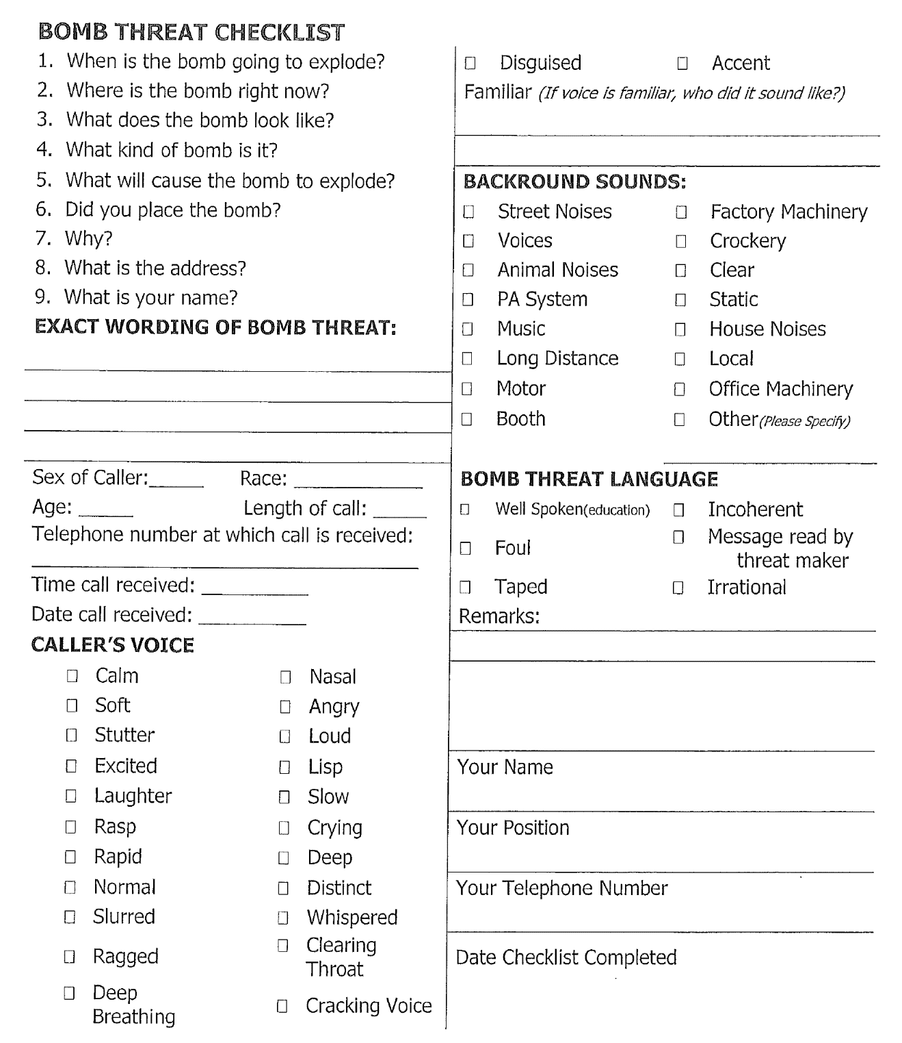

Employee Acknowledgment Form

Acknowledgement Form
For the Building Name Building Emergency Evacuation Plan.

I, ________________________________________ am officially stating that I received the
^{(print name)}

Building Name Building Emergency Evacuation Plan (Dated Month/Year). I understand that I am responsible for reading and adhering to these new policies effective immediately.

__________________________________________________ ____________________________
Signature Date

__________________________________________ ____________________________________
Division/Department Name Work Group (optional)

CC: Employee Personnel File/Non-Confidential

